

សាកលវិទ្យាល័យភូមិន្ទភ្នំពេញ
ROYAL UNIVERSITY OF PHNOM PENH
Department Computer Science
Software Engineering
Teach by
Dr. Svoey Bunna
Group 5
Topic :OOP & UML
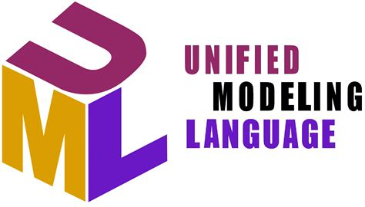

Members
1. ប៊ួយ រ៉ានី
2. នួន លក្ខិណា
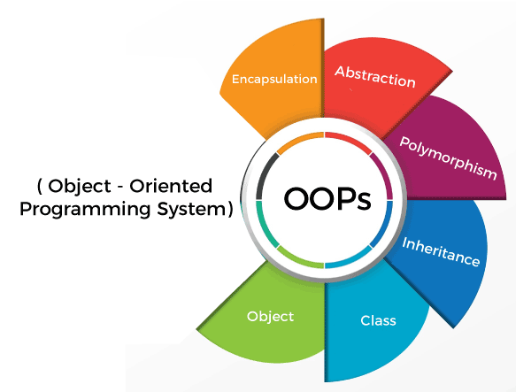
3. ថា សុគន្ធារី
4. គាំង ស៊ុនហ៊ាង
5. លឿង លីណា
6. ណែម បញ្ញា
7. ម៉ុក ចាន់បូ
8. បុត្រ ឆេងលី
Table of Contents
- OOPs Concepts:
  - Class
  - Objects
  - Data Abstraction
  - Encapsulation
  - Inheritance
  - Polymorphism
  - Dynamic Binding
  - Message Passing
- Object-Oriention: Concepts
- The Unified Modeling Language
  - Core UML Diagrams
    - Use Case Diagrams
    - Sequence Diagrams
    - Class Diagrams
  - Different Goals, Different Core Diagrams
- Class Normalization
  - First Object Normal Form (1ONF)
  - Second Object Normal Form (2ONF)
  - Third Object Normal Form (3ONF)
  - How Does Class Normalization Relate to Other Object Design Techniques?

Introduction of Object Oriented Programming
As the name suggests, Object-Oriented Programming or OOPs refers to languages that use objects in programming. Object-oriented programming aims to implement real-world entities like inheritance, hiding, polymorphism, etc in programming. The main aim of OOP is to bind together the data and the functions that operate on them so that no other part of the code can access this data except that function.

1. Class:
A class is a user-defined data type. It consists of data members and member functions, which can be accessed and used by creating an instance of that class. It represents the set of properties or methods that are common to all objects of one type. A class is like a blueprint for an object.
For Example: Consider the Class of Cars. There may be many cars with different names and brands but all of them will share some common properties like all of them will have 4 wheels, Speed Limit, Mileage range, etc. So here, Car is the class, and wheels, speed limits, mileage are their properties.
2. Object:
It is a basic unit of Object-Oriented Programming and represents the real-life entities. An Object is an instance of a Class. When a class is defined, no memory is allocated but when it is instantiated (i.e. an object is created) memory is allocated. An object has an identity, state, and behavior. Each object contains data and code to manipulate the data. Objects can interact without having to know details of each other’s data or code, it is sufficient to know the type of message accepted and type of response returned by the objects.
For example “Dog” is a real-life Object, which has some characteristics like color, Breed, Bark, Sleep, and Eats.
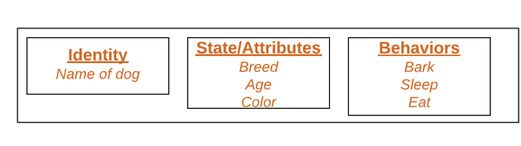Object
3. Data Abstraction:
Data abstraction is one of the most essential and important features of object-oriented programming. Data abstraction refers to providing only essential information about the data to the outside world, hiding the background details or implementation. Consider a real-life example of a man driving a car. The man only knows that pressing the accelerators will increase the speed of the car or applying brakes will stop the car, but he does not know about how on pressing the accelerator the speed is increasing, he does not know about the inner mechanism of the car or the implementation of the accelerator, brakes, etc in the car. This is what abstraction is.
4. Encapsulation:
Encapsulation is defined as the wrapping up of data under a single unit. It is the mechanism that binds together code and the data it manipulates. In Encapsulation, the variables or data of a class are hidden from any other class and can be accessed only through any member function of their class in which they are declared. As in encapsulation, the data in a class is hidden from other classes, so it is also known as data-hiding.
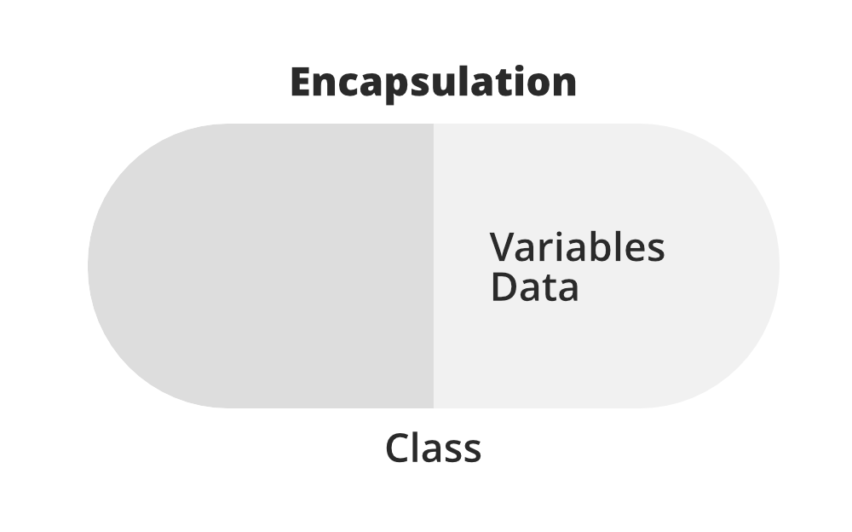
Consider a real-life example of encapsulation, in a company, there are different sections like the accounts section, finance section, sales section, etc. The finance section handles all the financial transactions and keeps records of all the data related to finance. Similarly, the sales section handles all the sales-related activities and keeps records of all the sales. Now there may arise a situation when for some reason an official from the finance section needs all the data about sales in a particular month. In this case, he is not allowed to directly access the data of the sales section. He will first have to contact some other officer in the sales section and then request him to give the particular data. This is what encapsulation is. Here the data of the sales section and the employees that can manipulate them are wrapped under a single name “sales section”.
5. Inheritance:
Inheritance is an important pillar of OOP(Object-Oriented Programming). The capability of a class to derive properties and characteristics from another class is called Inheritance. When we write a class, we inherit properties from other classes. So when we create a class, we do not need to write all the properties and functions again and again, as these can be inherited from another class that possesses it. Inheritance allows the user to reuse the code whenever possible and reduce its redundancy.
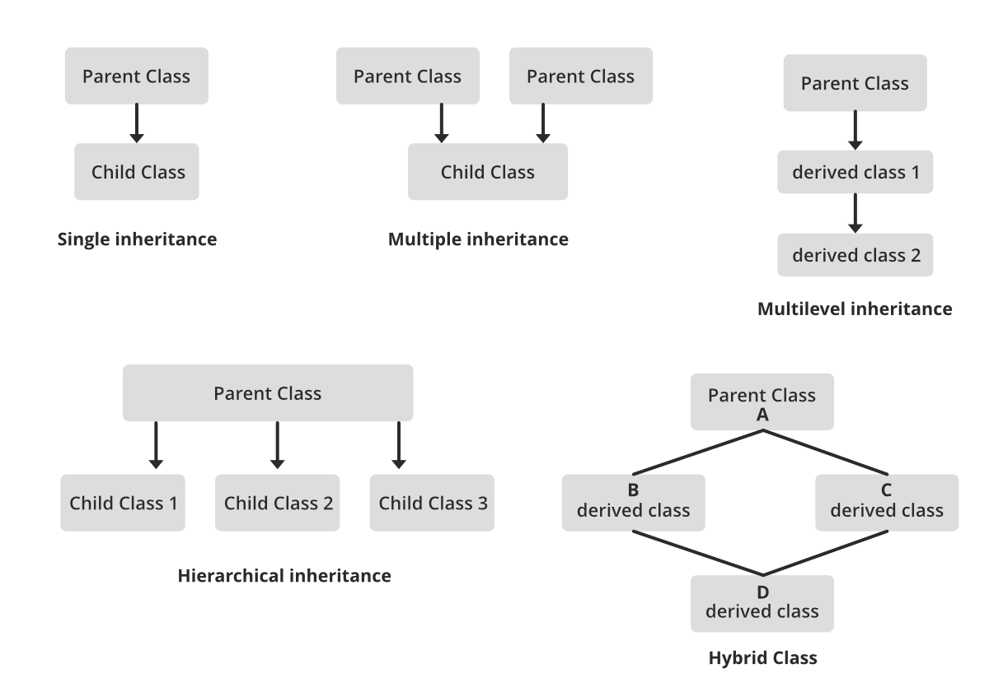
6. Polymorphism:
The word polymorphism means having many forms. In simple words, we can define polymorphism as the ability of a message to be displayed in more than one form. For example, A person at the same time can have different characteristics. Like a man at the same time is a father, a husband, an employee. So the same person posses different behavior in different situations. This is called polymorphism.
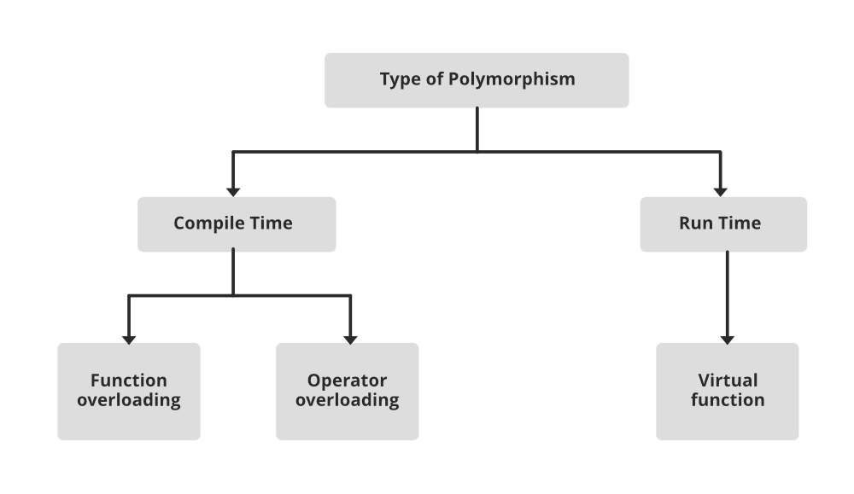
7. Dynamic Binding:
In dynamic binding, the code to be executed in response to the function call is decided at runtime. Dynamic binding means that the code associated with a given procedure call is not known until the time of the call at run time. Dynamic Method Binding One of the main advantages of inheritance is that some derived class D has all the members of its base class B. Once D is not hiding any of the public members of B, then an object of D can represent B in any context where a B could be used. This feature is known as subtype polymorphism.
8. Message Passing:
It is a form of communication used in object-oriented programming as well as parallel programming. Objects communicate with one another by sending and receiving information to each other. A message for an object is a request for execution of a procedure and therefore will invoke a function in the receiving object that generates the desired results. Message passing involves specifying the name of the object, the name of the function, and the information to be sent.
Why do we need object-oriented programming
- To make the development and maintenance of projects more effortless.
- To provide the feature of data hiding that is good for security concerns.
- We can solve real-world problems if we are using object-oriented programming.
- It ensures code reusability.
- It lets us write generic code: which will work with a range of data, so we don't have to write basic stuff over and over again.

1. Object-Oriention: Concepts
Agile software developers, including Agile data engineers, need to be familiar with the basic concepts of object-orientation. The object-oriented (OO) paradigm is a development strategy based on the concept that systems should be built from a collection of reusable components called objects. Instead of separating data and functionality as is done in the structured paradigm, objects encompass both. While the object-oriented paradigm sounds similar to the structured paradigm, as you will see at this site it is actually quite different. A common mistake that many experienced developers make is to assume that they have been “doing objects” all along just because they have been applying similar software-engineering principles. To succeed you must recognize that the OO approach is different than the structured approach.
To understand OO you need to understand common object terminology. The critical terms to understand are summarized in Table 1. I present a much more detailed explanation of these terms in The Object Primer 3/e. Some of these concepts you will have seen before, and some of them you haven’t. Many OO concepts, such as encapsulation, coupling, and cohesion come from software engineering. These concepts are important because they underpin good OO design. The main point to be made here is that you do not want to deceive yourself – just because you have seen some of these concepts before, it don’t mean you were doing OO, it just means you were doing good design. While good design is a big part of object-orientation, there is still a lot more to it than that.
Table 1. A summary of common object-oriented terms.
Term | Description
Abstract class | A class that does not have objects instantiated from it
Abstraction | The identification of the essential characteristics of an item
Aggregation | Represents “is part of” or “contains” relationships between two classes or components
Aggregation hierarchy | A set of classes that are related through aggregation
Association | Objects are related (associated) to other objects
Attribute | Something that a class knows (data/information)
Class | A software abstraction of similar objects, a template from which objects are created
Cohesion | The degree of relatedness of an encapsulated unit (such as a component or a class)
Collaboration | Classes work together (collaborate) to fulfill their responsibilities
Composition | A strong form of aggregation in which the “whole” is completely responsible for its parts and each “part” object is only associated to the one “whole”​​ object
Concrete class | A class that has objects instantiated from it
Coupling | The degree of dependence between two items
Encapsulation | The grouping of related concepts into one item, such as a class or component
Information hiding | The restriction of external access to attributes
Inheritance | Represents “is a” , “is like”, and “is kind of” relationships. When class “B” inherits from class “A” it automatically has all of the attributes and operations that “A” implements (or inherits from other classes)
Inheritance hierarchy | A set of classes that are related through inheritance
Instance | An object is an instance of a class
Instantiate | We instantiate (create) objects from classes
Interface | The definition of a collection of one or more operation signatures that defines a cohesive set of behaviors
Message | A message is either a request for information or a request to perform an action
Messaging | In order to collaborate, classes send messages to each other
Multiple inheritance | When a class directly inherits from more than one class
Multiplicity | A UML concept combining the data modeling concepts of cardinality (how many) and optionality.
Object | A person, place, thing, event, concept, screen, or report
Object space | Main memory + all available storage space on the network, including persistent storage such as a relational database
Operation | Something a class does (similar to a function in structured programming)
Override | Sometimes you need to override (redefine) attributes and/or methods in subclasses
Pattern | A reusable solution to a common problem taking relevant forces into account
Persistence | The issue of how objects are permanently stored
Persistent object | An object that is saved to permanent storage
Polymorphism | Different objects can respond to the same message in different ways, enable objects to interact with one another without knowing their exact type
Single inheritance | When a class directly inherits from only one class
Stereotype | Denotes a common usage of a modeling element
Subclass | If class “B” inherits from class “A,” we say that “B” is a subclass of “A”
Superclass | If class “B” inherits from class “A,” we say that “A” is a superclass of “B”
Transient object | An object that is not saved to permanent storage
It is important for Agile data engineers to understand the terms presented above because the application developers that you work with will use these terms, and many others, on a regular basis. To communicate effectively with application developers you must understand their vocabulary, and they must understand yours. Another important aspect of learning the basics of object orientation is to understand each of the diagrams of the Unified Modeling Language (UML) – you don’t need to become a UML expert, but you do need to learn the basics.

2. An Overview of The Unified Modeling Language
The goal of this section is to provide you with a basic overview of the UML, it is not to teach you the details of each individual technique. Much of the descriptiv material in this section is modified from The Elements of UML Style, a pocket-sized book that describes proven guidelines for developing high-quality and readable UML diagrams, and the examples from The Object Primer 3/e . A good starting point for learning the UML is UML Distilled as it is well written and concise. If you want a more thorough look at the UML, as well as other important models that the UML does not include, then you’ll find The Object Primer 3/e to be a better option.
It is also important to understand that you don’t need to learn all of the UML notation available to you, and believe me there’s a lot, but only the notation that you’ll use in practice. The examples presented in this section, there is one for each UML diagram, use the core UML. As you learn each diagram focus on learning the core notation first, you can learn the rest of the notation over time as you need to.

2.1 Core UML Diagrams
Let’s begin with what I consider to be the three core UML diagrams for developing business software: UML use case diagrams, UML sequence diagrams , and UML class diagrams. These are the diagrams that you will see used the most in practice – use case diagrams to overview usage requirements, sequence diagrams to analyze the use cases and map to your classes, and class diagrams to explore the structure of your object-oriented software (what I like to refer to as your object schema). These three diagrams will cover 80% of your object modeling needs when building a business application using object technology.

2.1.1 UML Use Case Diagrams
According to the UML specification a use case diagram is “a diagram that shows the relationships among actors and use cases within a system.” Use case diagrams are often used to:
- Provide an overview of all or part of the usage requirements for a system or organization in the form of an essential (Constantine and Lockwood 1999) model or a business model (Rational Corporation 2001)
- Communicate the scope of a development initiative
- Model the analysis of your usage requirements in the form of a system use case model (Cockburn 2001a)
Figure 1 depicts a simple use case diagram. This diagram depicts several use cases, actors, their associations, and optional system boundary boxes. A use case describes a sequence of actions that provide a measurable value to an actor and is drawn as a horizontal ellipse. An actor is a person, organization, or external system that plays a role in one or more interactions with your system. Actors are drawn as stick figures. Associations between actors and classes are indicated in use-case diagrams, a relationship exists whenever an actor is involved with an interaction described by a use case. Associations between actors and use cases are modeled as lines connecting them to one another, with an optional arrowhead on one end of the line indicating the direction of the initial invocation of the relationship.
Figure 1. A UML use case diagram.
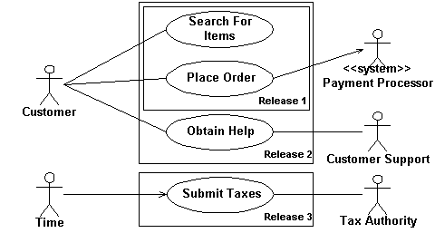

Associations also exist between use cases in system use case models and are depicted using dashed lines with the UML stereotypes of <<extend>> or <<include>>, as you see in Figure 2. It is also possible to model inheritance between use cases, something that is not shown in the diagram. The rectangle around the use cases is called the system boundary box and as the name suggests it delimits the scope of your system – the use cases inside the rectangle represent the functionality that you intend to implement.

Figure 2. Associations between use cases.
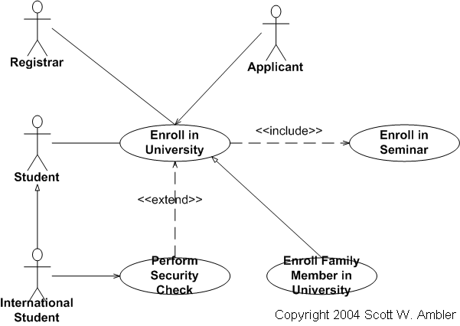

Figure 3 depicts an example of a use case diagram for a university information system. This is the level of detail that you would commonly see with use case diagrams in practice. A good reference is UML use case diagram style guidelines.

Figure 3. A use case diagram for university application.
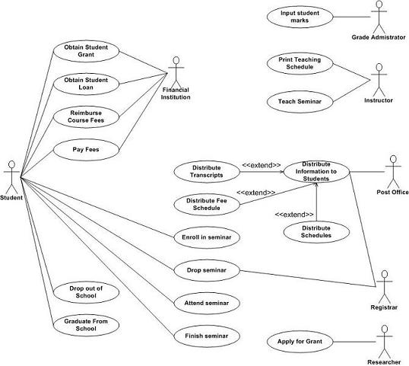

2.1.2 Object-Orientation: UML Sequence Diagrams
UML sequence diagrams are a dynamic modeling technique, as are collaboration diagrams and activity diagrams described below. UML sequence diagrams are typically used to:
- Validate and flesh out the logic of a usage scenario. A usage scenario is exactly what its name indicates – the description of a potential way that your system is used. The logic of a usage scenario may be part of a use case, perhaps an alternate course; one entire pass through a use case, such as the logic described by the basic course of action or a portion of the basic course of action plus one or more alternate scenarios; or a pass through the logic contained in several use cases, for example a student enrolls in the university then immediately enrolls in three seminars.
- Explore your design because they provide a way for you to visually step through invocation of the operations defined by your classes.
- To detect bottlenecks within an object-oriented design. By looking at what messages are being sent to an object, and by looking at roughly how long it takes to run the invoked method, you quickly get an understanding of where you need to change your design to distribute the load within your system. In fact some CASE tools even enable you to simulate this aspect of your software.
- Give you a feel for which classes in your application are going to be complex, which in turn is an indication that you may need to draw state chart diagrams for those classes.
For example Figure 4 models a portion of the basic course of action for the “Enroll in Seminar” use case. The boxes across the top of the diagram represent classifiers or their instances, typically use cases, objects, classes, or actors. Because you can send messages to both objects and classes, objects respond to messages through the invocation of an operation and classes do so through the invocation of static operations, it makes sense to include both on sequence diagrams. Because actors initiate and take an active part in usage scenarios they are also included in sequence diagrams. Objects have labels in the standard UML format “name: ClassName” where “name” is optional (objects that have not been given a name on the diagram are called anonymous objects). Classes have labels in the format “ClassName,” and actors have names in the format “Actor Name” – both common naming conventions.

Figure 4. A UML sequence diagram.
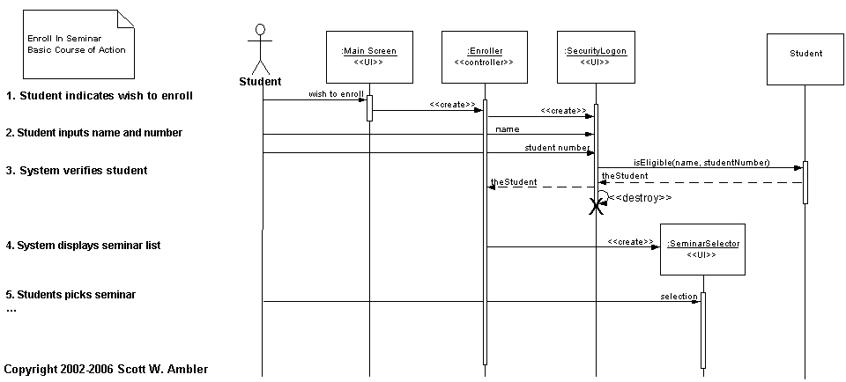

I have a tendency to hand draw sequence diagrams on whiteboards. Two such examples are show in Figure 5 and Figure 6. Figure 5 depicts a UML sequence diagram for the Enroll in University use case, taking a system-level approach where the interactions between the actors and the system are show. Similarly, Figure 6 depicts a sequence diagram for the detailed logic of a service to determine if an applicant is already a student at the university.
Figure 5. Enrolling in University.
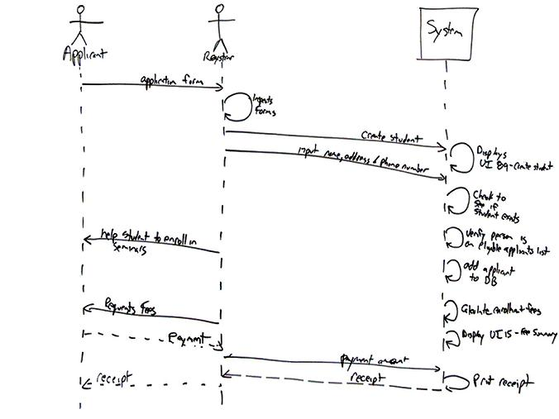

Figure 6. Searching for student records.
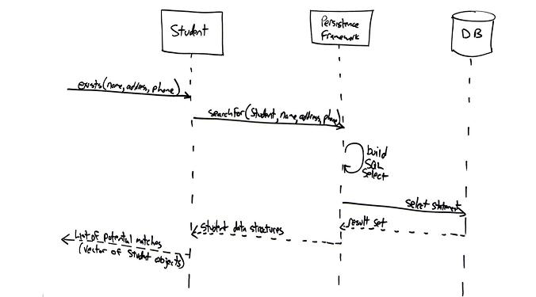

UML sequence diagramming is described in detail here, and a good style reference is UML sequence diagram style guidelines.

2.1.3 Object-Orientation: UML Class Diagrams
UML class diagrams show the classes of the system, their inter-relationships, and the operations and attributes of the classes. Class diagrams are typically used, although not all at once, to:
- Explore domain concepts in the form of a domain model
- Analyze requirements in the form of a conceptual/analysis model
- Depict the detailed design of object-oriented or object-based software
A class model is comprised of one or more class diagrams and the supporting specifications that describe model elements including classes, relationships between classes, and interfaces. Figure 3 depicts an example of an analysis UML class diagram. Classes are shown as boxes with three sections – the top for the name of the class, the middle for the attributes, and the bottom for the operations. Associations between classes are depicted as lines between classes. Associations should include multiplicity indicators at each end, for example 0..1 representing “zero or one” and 1..* representing “one or more”. Associations may have roles indicated, for example the mentors association, a recursive relation that professor objects have with other professor objects, indicates the roles of advisor and associate. A design class model would show greater detail. For example it is common to see the visibility and type of attributes depicted on design class diagrams as well as full operation signatures.

Figure 7. A UML class diagram.
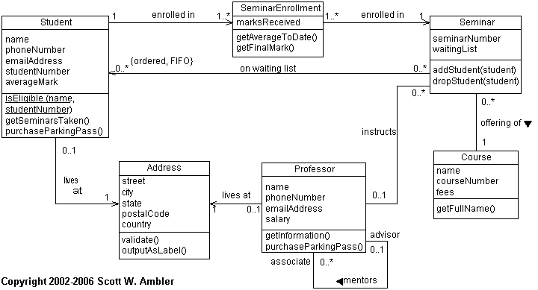

A detailed description of class diagramming is provided here, and a good style reference at UML class diagram style guidelines.

2.2 Different Goals, Different Core Diagrams
What happens if you’re not developing business application development, are their different core diagrams? Yes. For real-time or embedded systems the core diagrams are typically UML state machine diagrams, UML communication diagrams (or UML sequence diagrams depending on your team’s preference), and UML class diagrams. For architecture efforts the core diagrams are often UML deployment and UML component diagrams. All of these diagrams are valuable, in the right situations. Every agile software developer should learn how to work with these diagrams at some point in their careers, but they likely aren’t the first model types that you are likely to learn.

3. Object-Orientation: Class Normalization
In the data world there is a common process called data normalization by which you organize data in such a way as to reduce and even eliminate data redundancy, effectively increasing the cohesiveness of data entities. Can the techniques of data normalization be applied to object schemas? Yes, but this isn’t an ideal approach because data normalization only deals data and not behavior. We need to consider both when normalizing our object schema. We need to rethink our approach. Class normalization is a process by which you reorganize the structure of your object schema in such a way as to increase the cohesion of classes while minimizing the coupling between them.
Fundamentally class normalization is a technique for improving the quality of your object schemas. The exact same thing can be said of the application of common design pattern, such as those defined by the “Gang of Four (GoF)” in Design Patterns (Gamma et. al. 1995) . Design patterns are known solutions to common problems, examples of which include the Strategy pattern for implementing a collection of related algorithms and the Singleton pattern for implementing a class that only has one instance. The application of common design patterns will often result in a highly normalized object schema, although the overzealous application of design patterns can result in you overbuilding your software unnecessarily. As Agile Modeling (AM) suggests, you should follow the practice Apply Patterns Gentlyand ease into a design pattern over time.
Another common approach to improving object schemas is refactoring (Fowler 1999). Refactoring is a disciplined way to restructure code by applying small changes to your code to improve its design. Refactoring enables you to evolve your design slowly over time. Class normalization and refactoring fit together quite well – as you’re normalizing your classes you will effectively be applying many known refactorings to your object schema. A fundamental difference between class normalization and refactoring is that class normalization is typically performed to your models whereas refactorings are applied to your source code.
The UML Class diagram is a graphical notation used to construct and visualize object oriented systems. A class diagram in the Unified Modeling Language (UML) is a type of static structure diagram that describes the structure of a system by showing the system's:
- classes,
- their attributes,
- operations (or methods),
- and the relationships among objects.
What is a Class?
A Class is a blueprint for an object. Objects and classes go hand in hand. We can't talk about one without talking about the other. And the entire point of Object-Oriented Design is not about objects, it's about classes, because we use classes to create objects. So a class describes what an object will be, but it isn't the object itself.
In fact, classes describe the type of objects, while objects are usable instances of classes. Each Object was built from the same set of blueprints and therefore contains the same components (properties and methods). The standard meaning is that an object is an instance of a class and object - Objects have states and behaviors.
Example
A dog has states - color, name, breed as well as behaviors -wagging, barking, eating. An object is an instance of a class.
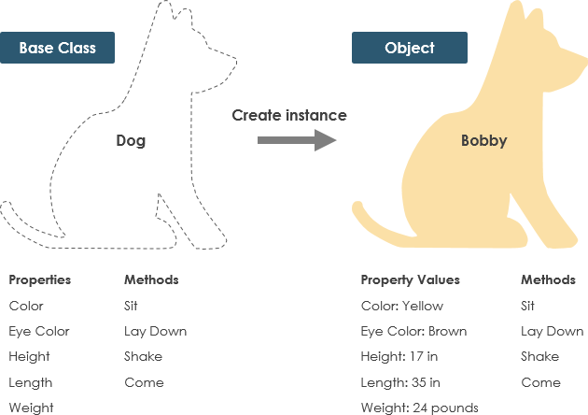
UML Class Notation
A class represent a concept which encapsulates state (attributes) and behavior (operations). Each attribute has a type. Each operation has a signature. The class name is the only mandatory information.
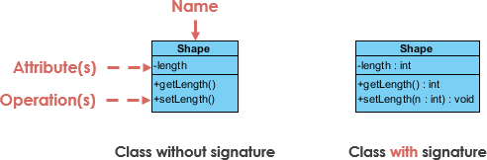
Class Name:
- The name of the class appears in the first partition.
Class Attributes:
- Attributes are shown in the second partition.
- The attribute type is shown after the colon.
- Attributes map onto member variables (data members) in code.
Class Operations (Methods):
- Operations are shown in the third partition. They are services the class provides.
- The return type of a method is shown after the colon at the end of the method signature.
- The return type of method parameters are shown after the colon following the parameter name. Operations map onto class methods in code
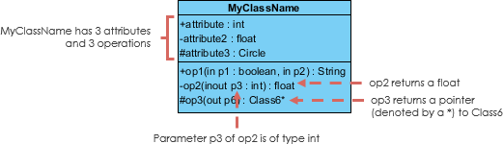
Class Visibility
The +, - and # symbols before an attribute and operation name in a class denote the visibility of the attribute and operation.
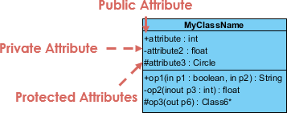
- + denotes public attributes or operations
- - denotes private attributes or operations
- # denotes protected attributes or operations
Parameter Directionality
Each parameter in an operation (method) may be denoted as in, out or inout which specifies its direction with respect to the caller. This directionality is shown before the parameter name.
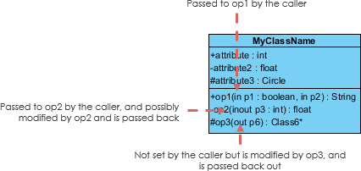
Perspectives of Class Diagram
The choice of perspective depends on how far along you are in the development process. During the formulation of a domain model, for example, you would seldom move past the conceptual perspective. Analysis models will typically feature a mix of conceptual and specification perspectives. Design model development will typically start with heavy emphasis on the specification perspective, and evolve into the implementation perspective.
A diagram can be interpreted from various perspectives:
- Conceptual: represents the concepts in the domain
- Specification: focus is on the interfaces of Abstract Data Type (ADTs) in the software
- Implementation: describes how classes will implement their interfaces
The perspective affects the amount of detail to be supplied and the kinds of relationships worth presenting. As we mentioned above, the class name is the only mandatory information.
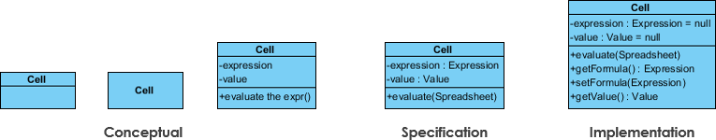
Relationships between classes
UML is not just about pretty pictures. If used correctly, UML precisely conveys how code should be implemented from diagrams. If precisely interpreted, the implemented code will correctly reflect the intent of the designer. Can you describe what each of the relationships mean relative to your target programming language shown in the Figure below?
If you can't yet recognize them, no problem this section is meant to help you to understand UML class relationships. A class may be involved in one or more relationships with other classes. A relationship can be one of the following types:
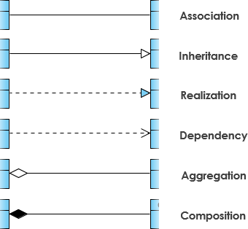
Inheritance (or Generalization):
A generalization is a taxonomic relationship between a more general classifier and a more specific classifier. Each instance of the specific classifier is also an indirect instance of the general classifier. Thus, the specific classifier inherits the features of the more general classifier.
- Represents an "is-a" relationship.
- An abstract class name is shown in italics.
- SubClass1 and SubClass2 are specializations of SuperClass.
The figure below shows an example of inheritance hierarchy. SubClass1 and SubClass2 are derived from SuperClass. The relationship is displayed as a solid line with a hollow arrowhead that points from the child element to the parent element.
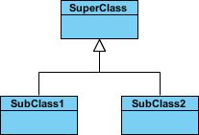
Inheritance Example - Shapes
The figure below shows an inheritance example with two styles. Although the connectors are drawn differently, they are semantically equivalent.
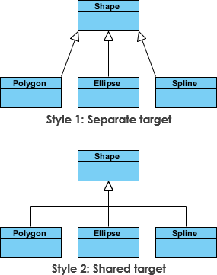
Association
Associations are relationships between classes in a UML Class Diagram. They are represented by a solid line between classes. Associations are typically named using a verb or verb phrase which reflects the real world problem domain.
Simple Association
- A structural link between two peer classes.
- There is an association between Class1 and Class2
The figure below shows an example of simple association. There is an association that connects the <<control>> class Class1 and <<boundary>> class Class2. The relationship is displayed as a solid line connecting the two classes.
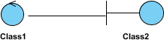
Cardinality
Cardinality is expressed in terms of:
- one to one
- one to many
- many to many
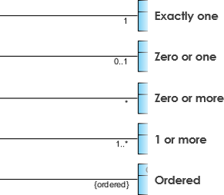
Aggregation
A special type of association.
- It represents a "part of" relationship.
- Class2 is part of Class1.
- Many instances (denoted by the *) of Class2 can be associated with Class1.
- Objects of Class1 and Class2 have separate lifetimes.
The figure below shows an example of aggregation. The relationship is displayed as a solid line with a unfilled diamond at the association end, which is connected to the class that represents the aggregate.
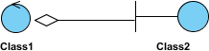
Composition
- A special type of aggregation where parts are destroyed when the whole is destroyed.
- Objects of Class2 live and die with Class1.
- Class2 cannot stand by itself.
The figure below shows an example of composition. The relationship is displayed as a solid line with a filled diamond at the association end, which is connected to the class that represents the whole or composite.
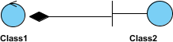
Dependency
An object of one class might use an object of another class in the code of a method. If the object is not stored in any field, then this is modeled as a dependency relationship.
- A special type of association.
- Exists between two classes if changes to the definition of one may cause changes to the other (but not the other way around).
- Class1 depends on Class2
The figure below shows an example of dependency. The relationship is displayed as a dashed line with an open arrow.
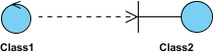
The figure below shows another example of dependency. The Person class might have a hasRead method with a Book parameter that returns true if the person has read the book (perhaps by checking some database).
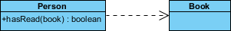
Realization
Realization is a relationship between the blueprint class and the object containing its respective implementation level details. This object is said to realize the blueprint class. In other words, you can understand this as the relationship between the interface and the implementing class.
For example, the Owner interface might specify methods for acquiring property and disposing of property. The Person and Corporation classes need to implement these methods, possibly in very different ways.
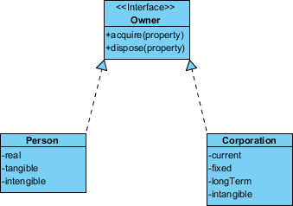
Class Diagram Example: Order System
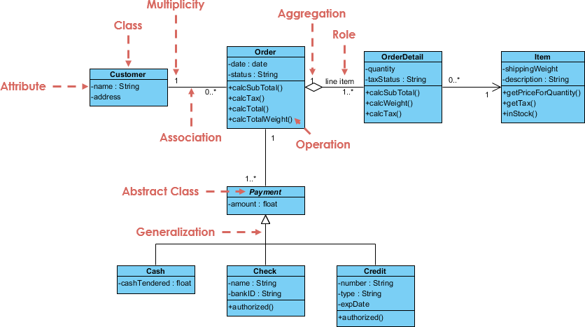
Class Diagram Example: GUI
A class diagram may also have notes attached to classes or relationships.
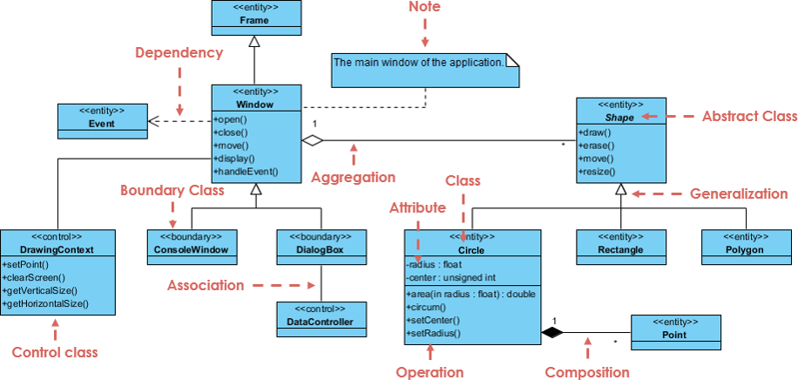

UML Class Diagram
A UML class diagram visually represents the structure of a system by showing its classes, attributes, methods, and the relationships between them.
- Helps everyone involved in a project—like developers and designers—understand how the system is organized and how its components interact.
- Helps to communicate and document the structure of the software.
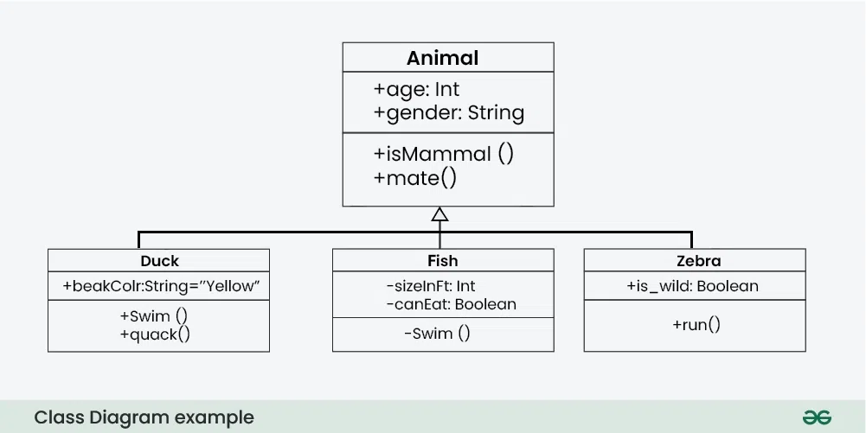
UML Class Notation
Classes are depicted as boxes, each containing three compartments for the class name, attributes, and methods.
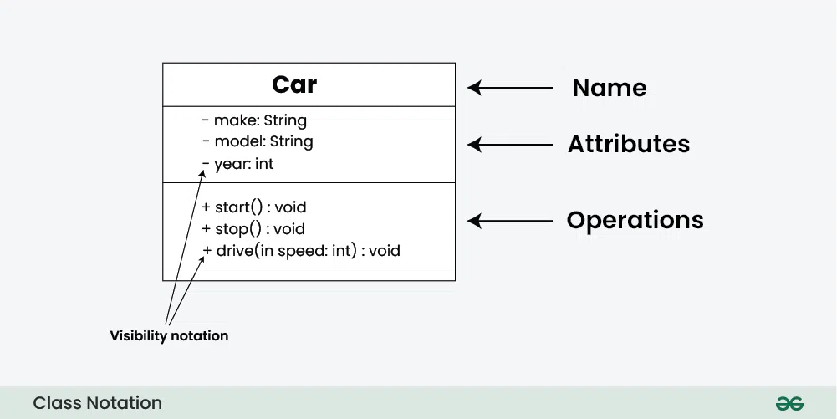
- Class Name:
  - The name of the class is typically written in the top compartment of the class box and is centered and bold.
- Attributes:
  - Attributes, also known as properties or fields, represent the data members of the class. They are listed in the second compartment of the class box and often include the visibility (e.g., public, private) and the data type of each attribute.
- Methods:
  - Methods, also known as functions or operations, represent the behavior or functionality of the class. They are listed in the third compartment of the class box and include the visibility (e.g., public, private), return type, and parameters of each method.
- Visibility Notation:
  - Visibility notations indicate the access level of attributes and methods. Common visibility notations include:
    - + for public (visible to all classes)
    - - for private (visible only within the class)
    - # for protected (visible to subclasses)
    - ~ for package or default visibility (visible to classes in the same package)
Parameter Directionality
- In class diagrams, parameter directionality refers to the indication of the flow of information between classes through method parameters.
- It helps to specify whether a parameter is an input, an output, or both. This information is crucial for understanding how data is passed between objects during method calls.
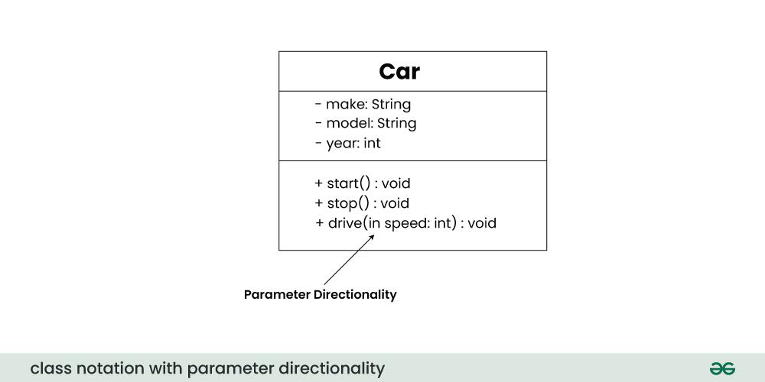
There are three main parameter directionality notations used in class diagrams:
- In (Input):
  - An input parameter is a parameter passed from the calling object (client) to the called object (server) during a method invocation.
  - It is represented by an arrow pointing towards the receiving class (the class that owns the method).
- Out (Output):
  - An output parameter is a parameter passed from the called object (server) back to the calling object (client) after the method execution.
  - It is represented by an arrow pointing away from the receiving class.
- InOut (Input and Output):
  - An InOut parameter serves as both input and output. It carries information from the calling object to the called object and vice versa.
  - It is represented by an arrow pointing towards and away from the receiving class.
Relationships between classes
In class diagrams, relationships between classes describe how classes are connected or interact with each other within a system. Here are some common types of relationships in class diagrams:
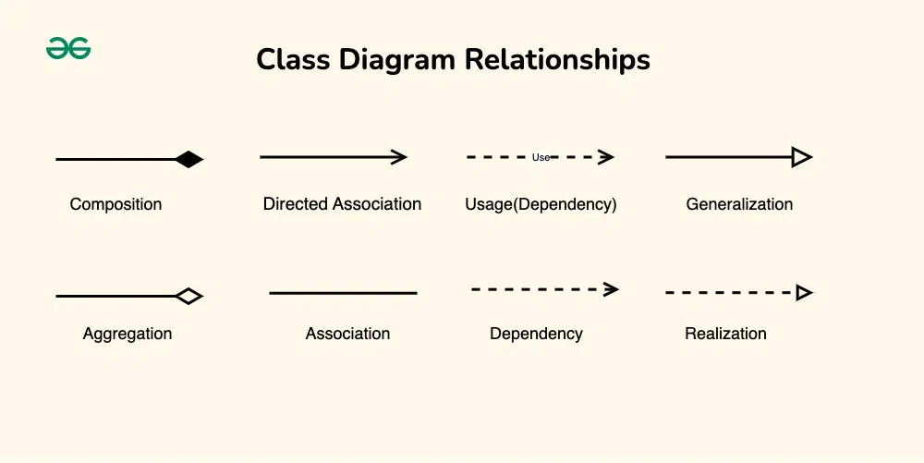
1. Association
An association represents a bi-directional relationship between two classes. It indicates that instances of one class are connected to instances of another class. Associations are typically depicted as a solid line connecting the classes, with optional arrows indicating the direction of the relationship.
2. Directed Association
A directed association in a UML class diagram represents a relationship between two classes where the association has a direction, indicating that one class is associated with another in a specific way.
3. Aggregation
Aggregation is a specialized form of association that represents a "whole-part" relationship. It denotes a stronger relationship where one class (the whole) contains or is composed of another class (the part). Aggregation is represented by a diamond shape on the side of the whole class. In this kind of relationship, the child class can exist independently of its parent class.
4. Composition
Composition is a stronger form of aggregation, indicating a more significant ownership or dependency relationship. In composition, the part class cannot exist independently of the whole class. Composition is represented by a filled diamond shape on the side of the whole class.
5. Generalization(Inheritance)
Inheritance represents an "is-a" relationship between classes, where one class (the subclass or child) inherits the properties and behaviors of another class (the superclass or parent). Inheritance is depicted by a solid line with a closed, hollow arrowhead pointing from the subclass to the superclass.
6. Realization (Interface Implementation)
Realization indicates that a class implements the features of an interface. It is often used in cases where a class realizes the operations defined by an interface. Realization is depicted by a dashed line with an open arrowhead pointing from the implementing class to the interface.
7. Dependency Relationship
A dependency exists between two classes when one class relies on another, but the relationship is not as strong as association or inheritance. It represents a more loosely coupled connection between classes.
8. Usage(Dependency) Relationship
A usage dependency relationship in a UML class diagram indicates that one class (the client) utilizes or depends on another class (the supplier) to perform certain tasks or access certain functionality. The client class relies on the services provided by the supplier class but does not own or create instances of it.
- In UML class diagrams, usage dependencies are typically represented by a dashed arrowed line pointing from the client class to the supplier class.
- The arrow indicates the direction of the dependency, showing that the client class depends on the services provided by the supplier class.
Purpose of Class Diagrams
The main purpose of using class diagrams is:
- This is the only UML that can appropriately depict various aspects of the OOPs concept.
- Proper design and analysis of applications can be faster and efficient.
- It is the base for deployment and component diagram.
- It incorporates forward and reverse engineering.
Benefits of Class Diagrams
Below are the benefits of class diagrams:
- Class diagrams represent the system's classes, attributes, methods, and relationships, providing a clear view of its architecture.
- They shows various relationships between classes, such as associations and inheritance, helping stakeholders understand component connectivity.
- Class diagrams serve as a visual tool for communication among team members and stakeholders, bridging gaps between technical and non-technical audiences.
- They guide developers in coding by illustrating the design, ensuring consistency between the design and actual implementation.
- Many development tools allow for code generation from class diagrams, reducing manual errors and saving time.

